**Guided Cap Report - Big Mountain Resort**

Big Mountain Resort had installed an additional chairlift to help increase the distribution of visitors across the mountain. The additional chairlift increases their operating cost by $1,540,000 this season. This is a large operating cost that will affect its operating income and net revenue. That is why it was decided to look into the resort’s current pricing strategy to determine if charging a premium over the average price of resorts in comparison to its competitors is the best way to beat the market. In order to compensate for this cost investment, Big Mountain Resort had to determine whether to change their ticket prices. After analysis, there were indications that the resort was not capitalizing on its features based on its current ticketing price.

We came up with 4 scenarios to come up with the ticket prices. The first scenario is to close up to 10 of the least used runs. Scenario 2 involves Big Mountain Resort adding a run, increasing a vertical drop by 150 feet and installing an additional chairlift to bring customers back up. Scenario 3 is an addition to increasing the vertical drop by 150 feet and installing an additional chairlift, but also adding 2 acres of snow making. Scenario 4 is to add to the longest run by .2 miles and guarantee the snow coverage by adding 4 acres of snow making capability.

Looking at the 1st scenario, we have come up with a visualization to identify the drops of ticketing prices and revenue when closing runs. As show below, here are the changes when confirming closures of runs:

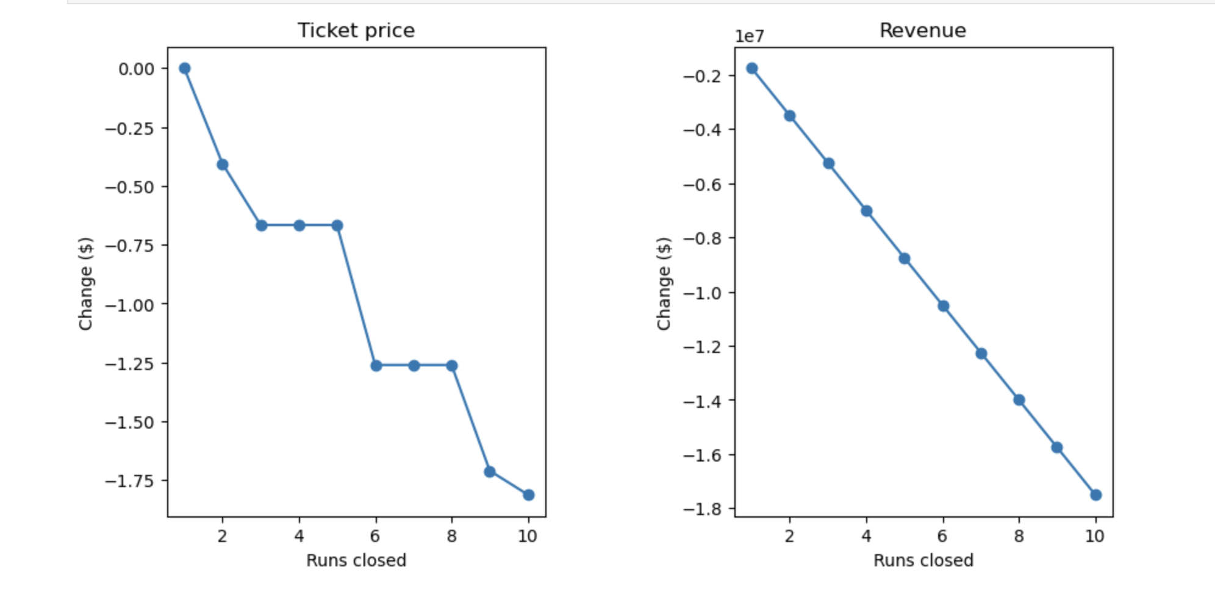

As seen above, the model indicates closing two, three runs reduces ticket prices and revenue, while closing four or five runs show no significant change in ticket price. Closing four to five runs show a drop of about $500,000 in revenue and any further drop of runs (5+) would substantially lower the revenue and ticket prices by almost three times.

The next models aiming to raise prices and introduce new features revealed insights. Specifically, elevating the vertical drop by 150 feet was associated with a projected price increase of $8.67 per ticket, contributing to an estimated revenue increase of approximately $15 million. Similarly, establishing snow making over 2 acres within the same model showed a potential ticket price increase of $10.59, resulting in an additional $3.5 million in revenue, summing up to a total of $18.5 million. However, the final model, involving an extension of the longest run by 0.2 miles and ensuring snow coverage through the addition of 4 acres of snow making, showed no discernible impact on ticket pricing.

The scenario involving a 150-foot increase in vertical drop, appears to be the pragmatic choice for exploration. This is because scenarios related to closing runs and extending the longest run contribute less (closing runs) or show no change (increasing the longest run) in revenue. The ticket increases by $8.61 and revenue increases by $15,065,471. However, it's essential to examine the option of adding snow making to the heightened vertical drop. While this enhancement could potentially increase revenue by $3.5 million compared to the same option without additional snow making, it will require extra operating costs (snow making). The question is whether the supplementary cost for snow making justifies the $1.99 increase in prices. To make an informed decision, further analysis is warranted, incorporating additional data such as the expenses associated with snow making, assessing the optics of an $8.67 increase, and evaluating the feasibility of accommodating visitors in the expanded snow area and the costs of that whether it is increasing staff and training.